Name: Ali Albayrak

Student ID: P304320

Regular Expressions Test Documentation

Testing with Code Sniffer:

Before fixing:

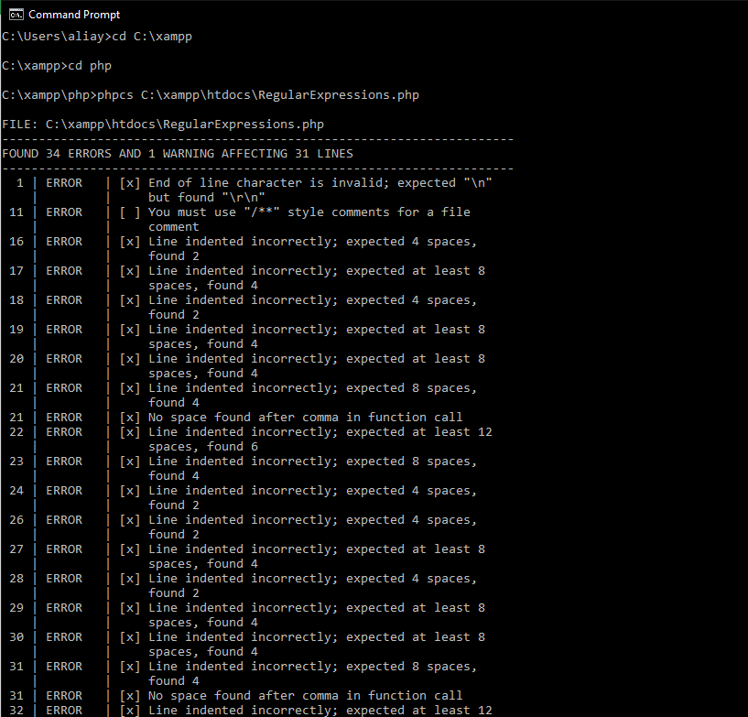

After fixing:

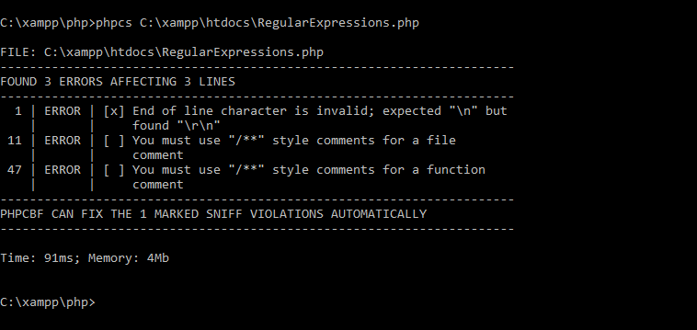

Test Table:

|  |  |  |  |  |
| --- | --- | --- | --- | --- |
| Test No | Name | Email | Comment | Expected Output |
| 1 | Ali | [ali@hotmail.com](mailto:ali@hotmail.com) | Test no 1 | Valid |
| 2 | Alex`s | [alex@hotmail.com.au](mailto:alex@hotmail.com.au) | Test no 2 | Valid |
| 3 | Chris-ongo | [chris@aaa.bb.net](mailto:chris@aaa.bb.net) | Test no 3 | Valid |
| 4 | Angela21 | Angela.com@ttt.com | Test no 4 | Invalid Name, Valid Email |
| 5 | Ricardo Dougla`s | D.ricardo.21@abc.def | Test no 5 | Valid Name, Invalid Email |
| 6 | E`bonn`es Saye-e Eto-o | Sayee.etoo | Test no 6 | Valid Name, Invalid Email |

Results:

Test NO:

1:

Chrome:

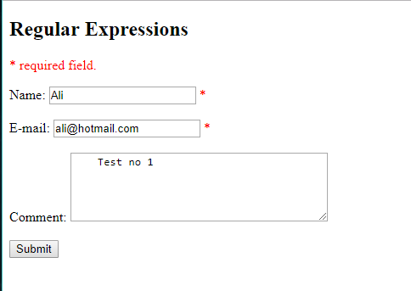

Mozilla Firefox:

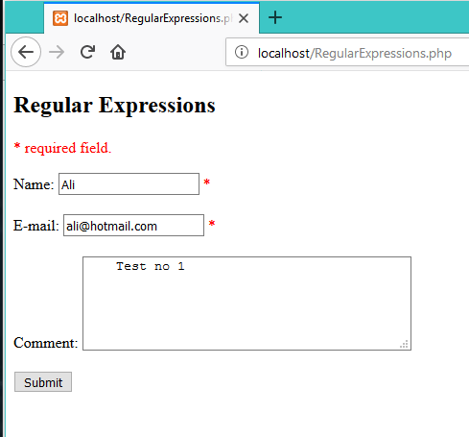

Test no 2:

Chrome:

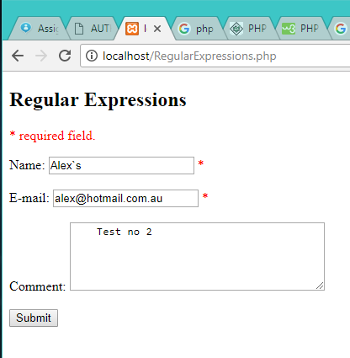

Firefox:

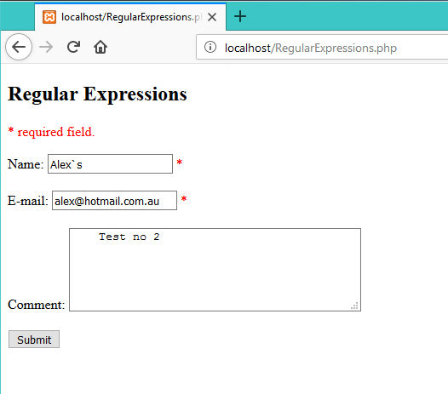

Test No 3:

Chrome:

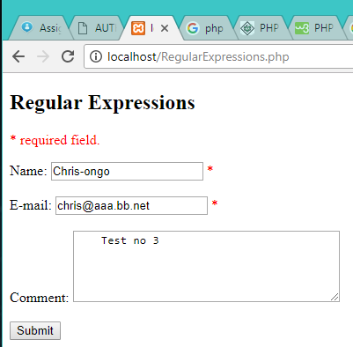

Firefox:

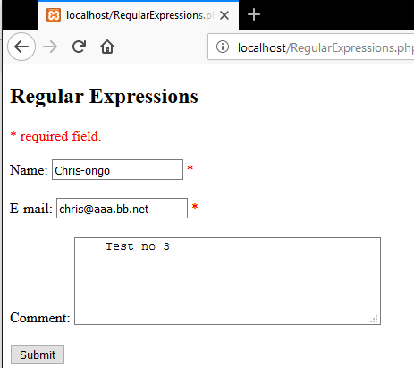

Test No 4:

Chrome:

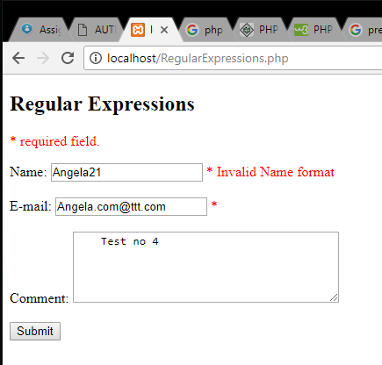

Firefox:

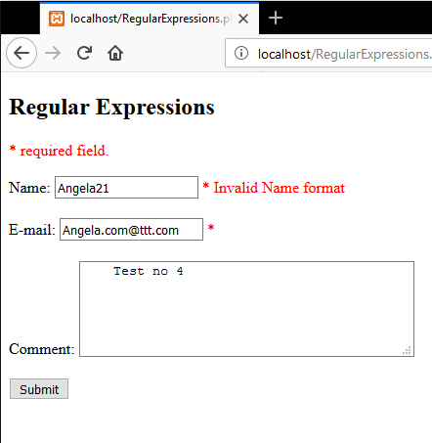

Test No 5:

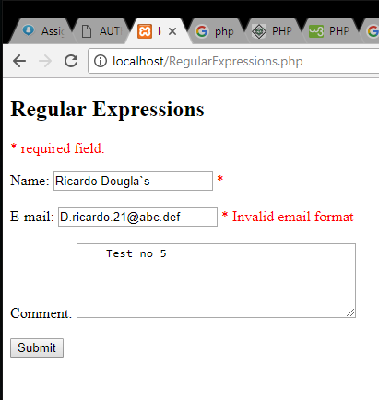

Firefox:

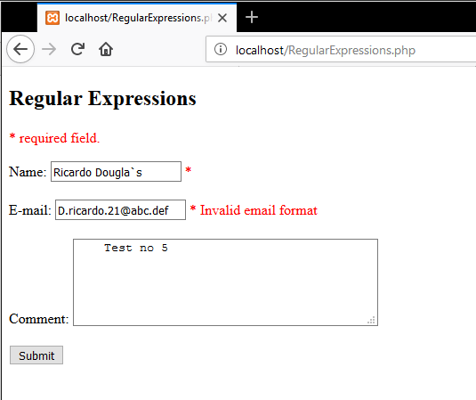

Test No 6:

Chrome:

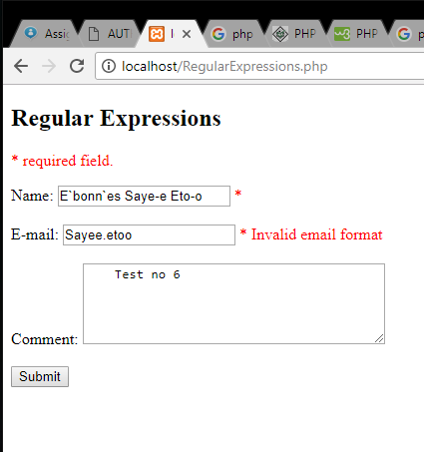

Firefox:

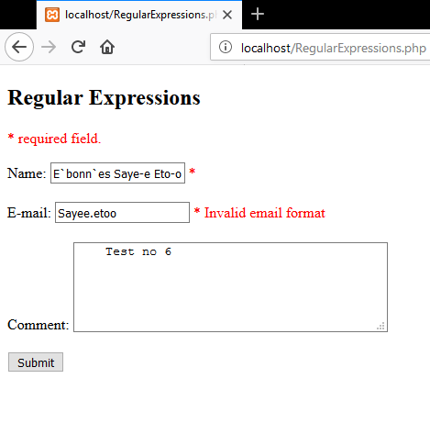

Result:

All of the test results are as expected. There are no errors or unexpected outcome.